Chapter 6

Database Notice

In this project’s database, changes in some tables are cascaded, which means, when there is an entry in a table gets updated or deleted, its associated entries in other tables will be correspondingly updated or deleted. User should be cautious of this.

6.1 Delete A User in the Database

In the database, there is a table named User which stores a user’s name and his user type. If a certain user is removed from database, then any records associated with him will be removed either.

An example is given as followed:

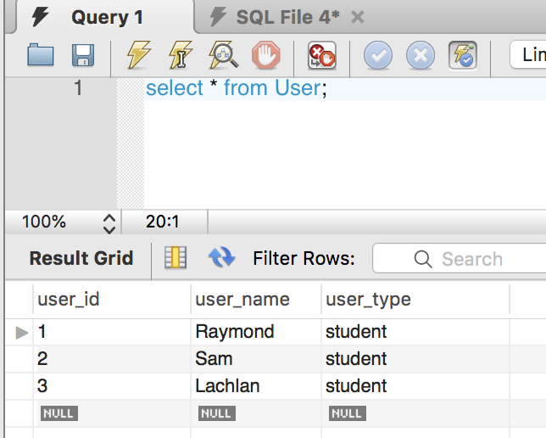

Figure 6.1 Original User Table

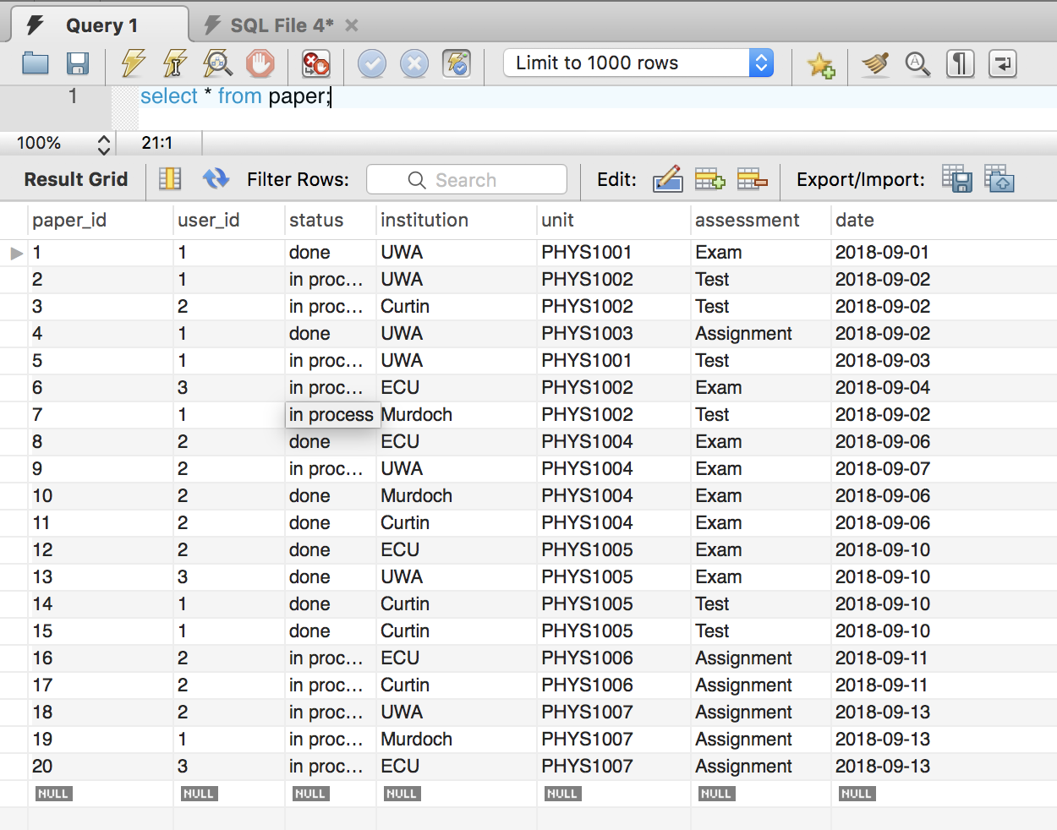

Figure 6.2 Original Paper Table

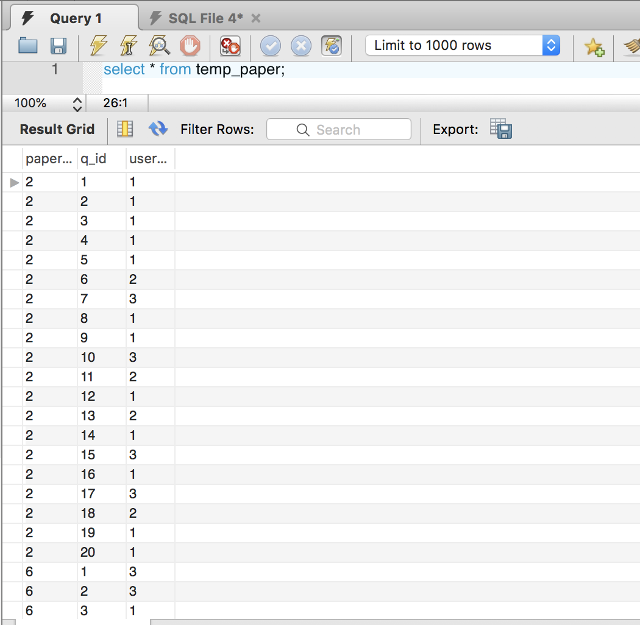

Figure 6.3 Original Temp_Paper Table

Now, if we delete the user with the user id equals to 2.

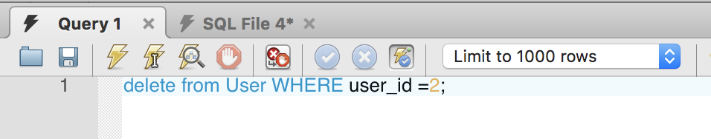

Figure 6.4 Execution Query

Then first we can see user Sam’s record is removed from the User table.

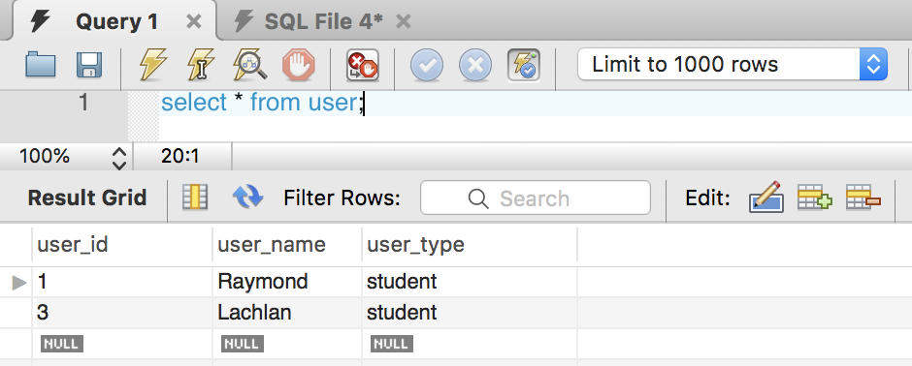

Figure 6.5 New User Table

All records associated with Sam in Paper and Temp_Paper table are all removed.

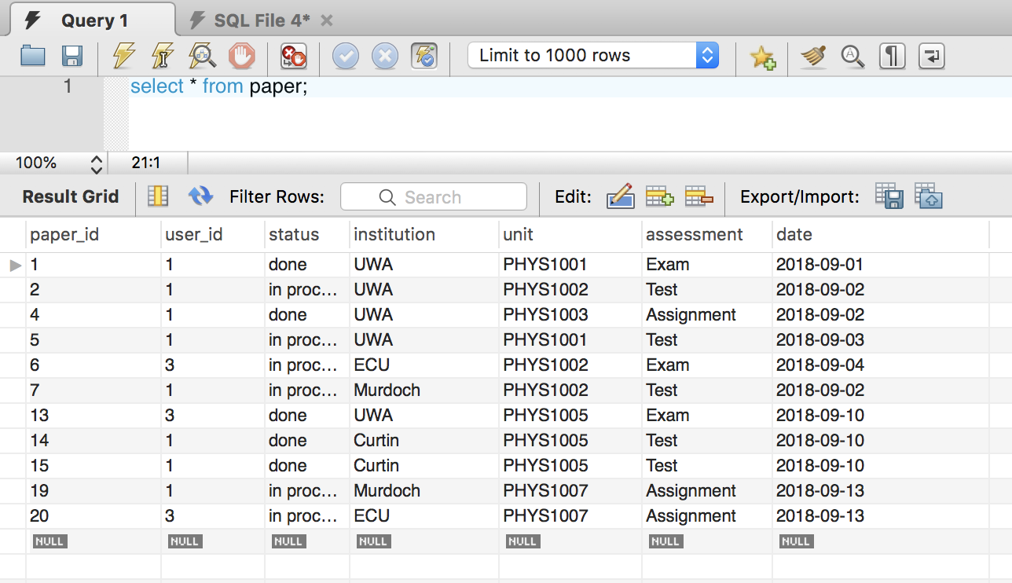

Figure 6.6 New Paper Table

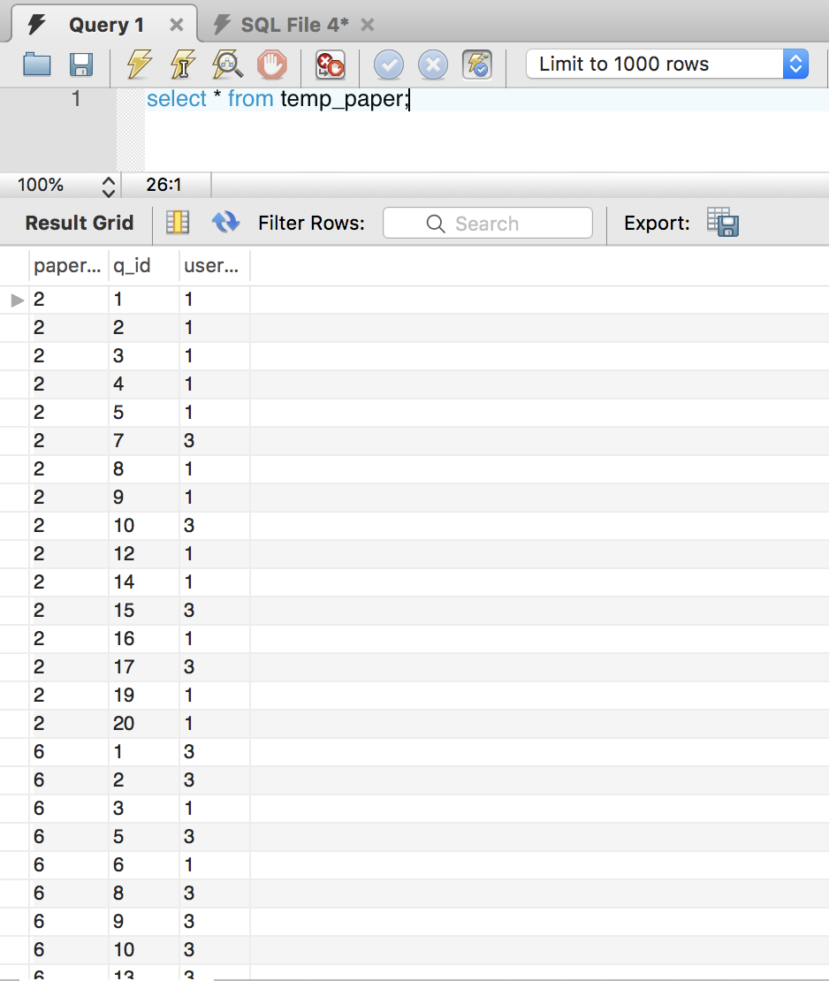

Figure 6.7 New Temp_Paper Table